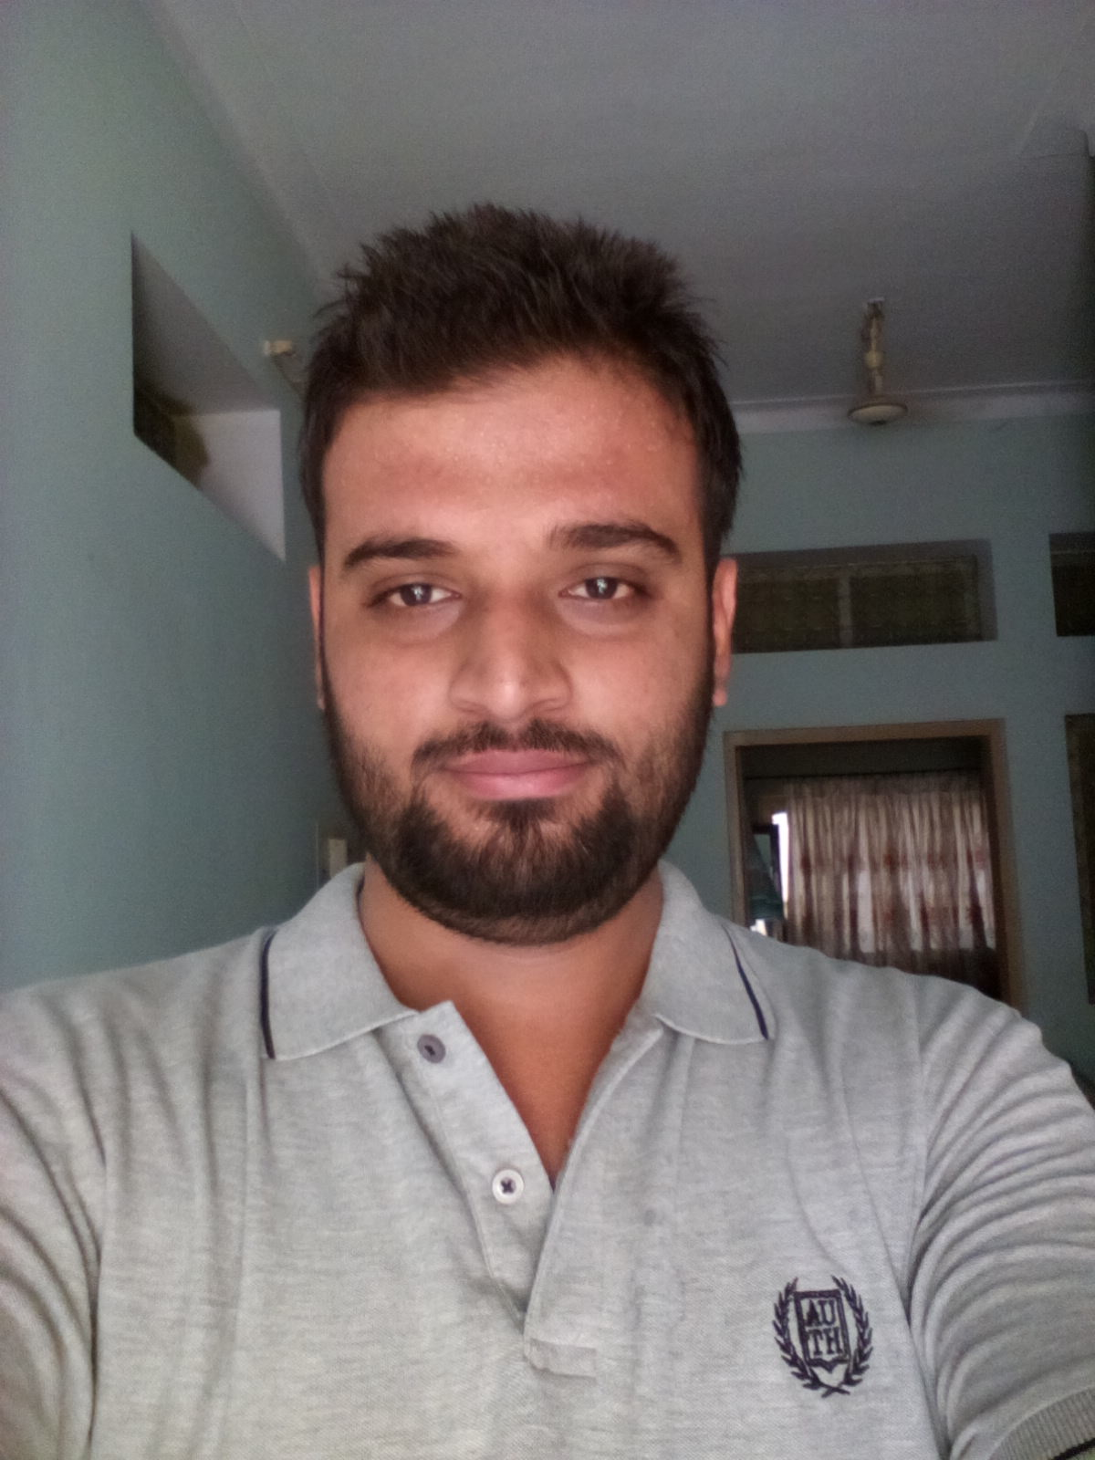
Hadi Sarwar

Residence: 265 G Block, Sabzazar lahore.
Postal Code: 53700

 Mobile: + 92-322-7073918
 E-Mail: hadisarwar90 @gmail.com

PERSONAL STATISTICS:

Father’s Name Javad Sarwar
Dob 16-10-1991
Marital Status Single

QUALIFICATION

- BSCS ( 2011-15)
The University Of Lahore
CGPA: 2.4/4

- ICS.COMPUTER SCIENCE (2008-2010)
GOURMENT COLLEGE SAHIWAL
Marks: 647/1100

- Matriculation –Science (2008-10)
THE EDUCATOR HIGH SCHOOL
Marks: 511/850

PROGRAMMING LANGUAGES
Java, C#, C, C++, asp.net, SQL, PHP, JavaScript, Html, CSS,Bootstrap Assembler

DATABASE SERVERS
Microsoft SQL Server MySQL, Microsoft Access (2000, 2003)

DEVELOPMENT TOOLS
Eclipse, NetBeans
Microsoft Visual Studio
Macromedia Dreamweaver
Microsoft Office
Adobe Photoshop

OTHER SKILLS
Leadership, Team working skills, Communication skills, Presentation skills, teaching skills

JOB EXPERIENCE

- 3 month front end development in Crew Logix Lahore

